Zoom Around the World

The Central Jersey Twelfth-Step-Within Committee has a challenge for you! Go to a meeting in every Region in the world, keep your records on the sheet below, and email the completed form to oafrank571@gmail.com by December 9, 2020. All completed forms will be entered in a raffle to win a copy of OA’s newly published book, “Body Image, Relationships, and Sexuality”. See the following pages for lists of Regions and the states/countries that comprise and start connecting with our worldwide fellowship today! Together we can… Recover!

Name: Email:
Are you a member of CJIOA? Yes _____ No _____

REGIONS | MEETING DAY/TIME | COUNTRY/STATE | TOPIC/SPECIAL FOCUS
Region 1
Region 2
Region 3
Region 4
Region 5
Region 6
Region 7
Region 8
Region 9
Region 10
Virtual Region

To get you started here is a list of all of the OA Regions, as well a link that will direct you to an Intergroup Zoom meeting in that region:

Region 1
1. http://www.centraloregonoa.org Oregon
Pacific North West: Alaska, Idaho, Montana, Oregon, Washington, Wyoming, Alberta, British Columbia, Northwest Territories, Saskatchewan, Yukon
Region 2
1. http://www.oasf.org San Francisco area
Pacific Southwest: California, Hawaii, Reno/Tahoe area of Nevada, Mexico Region 3
1. http://www.oahawaii.org Hawaii
Southwest: Arizona, Colorado, Nevada, New Mexico, Oklahoma, Texas, Utah Region 4
1. http://www.cii.oaregion4.org Central Iowa
West Central: Illinois (except the Greater Chicago area and Central Illinois Intergroup), Iowa, Kansas, Minnesota, Missouri, Nebraska, North Dakota, South Dakota, Manitoba, Northwestern Ontario, the territory of Nunavut.
Region 5
1. http://www.oagreaterdetroit.org Detroit area
Central: Greater Chicago area and Central Illinois Intergroup, Indiana, Kentucky, Michigan, Ohio, Wisconsin, Southwestern Ontario
Region 6
1. http://www.oceanandbay.org Rhode Island and S.E. Massachusetts Northeast: Connecticut, Maine, Massachusetts, New Hampshire, New York, Rhode Island, Vermont, New Brunswick, Newfoundland and Labrador, Nova Scotia, Ontario, Prince Edward Island, Quebec, Bermuda
Region 7
1. http://www.oadelaware.org Delaware
Eastern: Delaware, District of Columbia, Maryland, New Jersey, Pennsylvania, Virginia, West Virginia
Region 8
1. http://www.oapalmbeachfl.org Palm Beach Florida
Southeast: Alabama, Arkansas, Florida, Georgia, Louisiana, Mississippi, North Carolina, Puerto Rico, South Carolina, Tennessee, the Virgin Islands, Central America, South America
Region 9
1. http://www.oagb.org.uk Great Britain
Countries and territories in Africa, Europe, the Middle East, Western Asia Region 10
1. http://www.oasydney.org Sydney, Australia
Countries and territories in Australia, New Zealand, South East Asia, the Western Pacific Basin
Virtual Region
1. http://www.oa12step4coes.org 12 Step 4 COE's

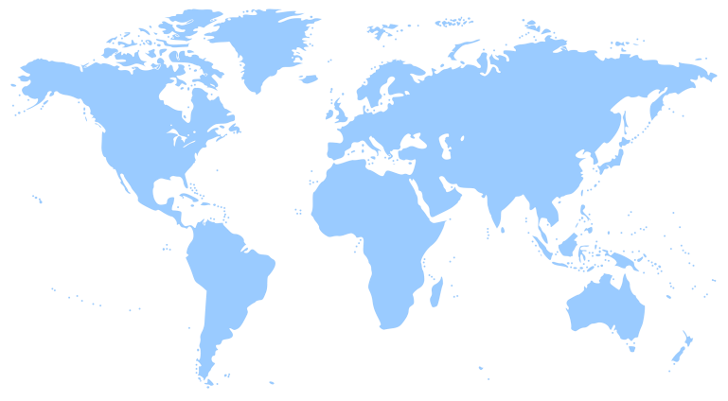

But if you’re up for a challenge and wish to find your own meetings, we encourage you to explore on your own by doing the following:

Tips on How to Find a Virtual Meeting Using the Zoom Platform

Go to: OA Online Meetings (Find A Meeting)

https://oa.org/find-a-meeting/?type=0

or

Search the Internet with these specific words:

Overeaters Anonymous Zoom (don’t put quotes around it)

A multiple of listings will pop-up for Intergroups and Regions with lists of local meetings. If you don’t specific area you want, go to bottom of search and
choose “NEXT.”
Remember: All OA meetings are open to anyone with a desire to stop eating compulsively.

~Please note the raffle is only open to members of Central Jersey OA Members, but we encourage all members of OA to Zoom around the world ~

If you have any questions please email: oafrank571@gmail.com

